Pipelines through BC
Lately in the news there is more talk of expanding Canada’s Oil and Gas export. Alberta would like to have a pipeline to the north coast of BC at Kitimat or Prince Rupert, both deep water ports.
Why are Deep Water Ports important places to end a pipeline?

What is the difference between Bitumen, Natural Gas and Oil in terms of how it is transported and shipped?

Choose a recent news title about the Pipeline issue and describe the nature of the article or video.
Title ___________________________________________________________________________

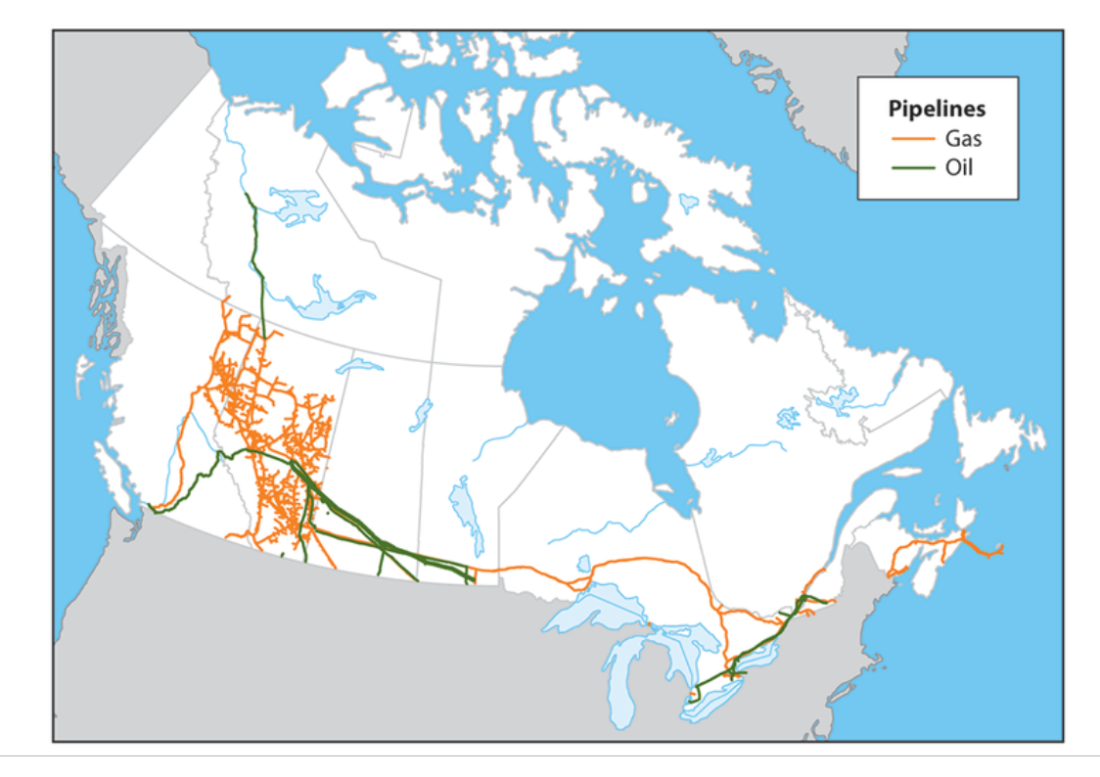

Based on the map above where is most of the fossil fuel industry in Canada? How does the existing pipeline correspond with serving the populated areas of the country?

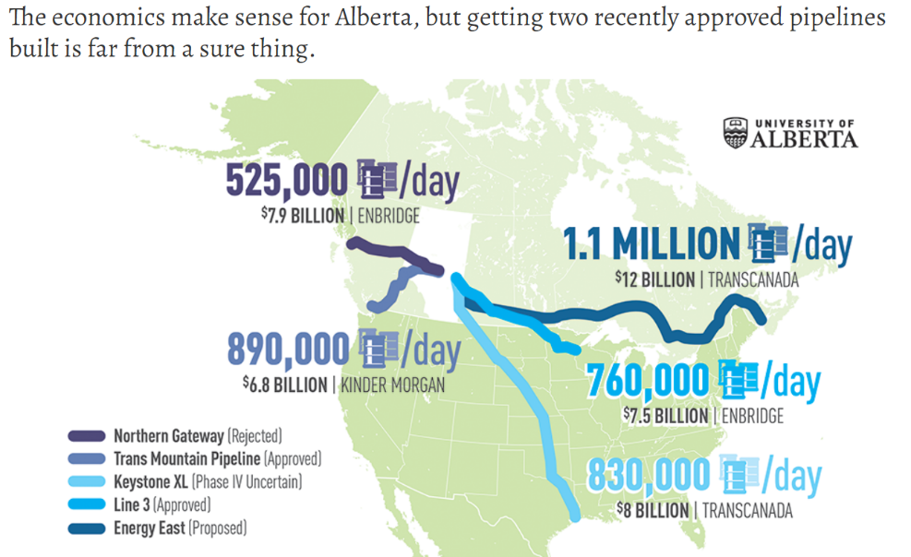

Research the price of oil per barrel right now. Which of the above pipelines would be the most profitable and how much money per day are we talking about?

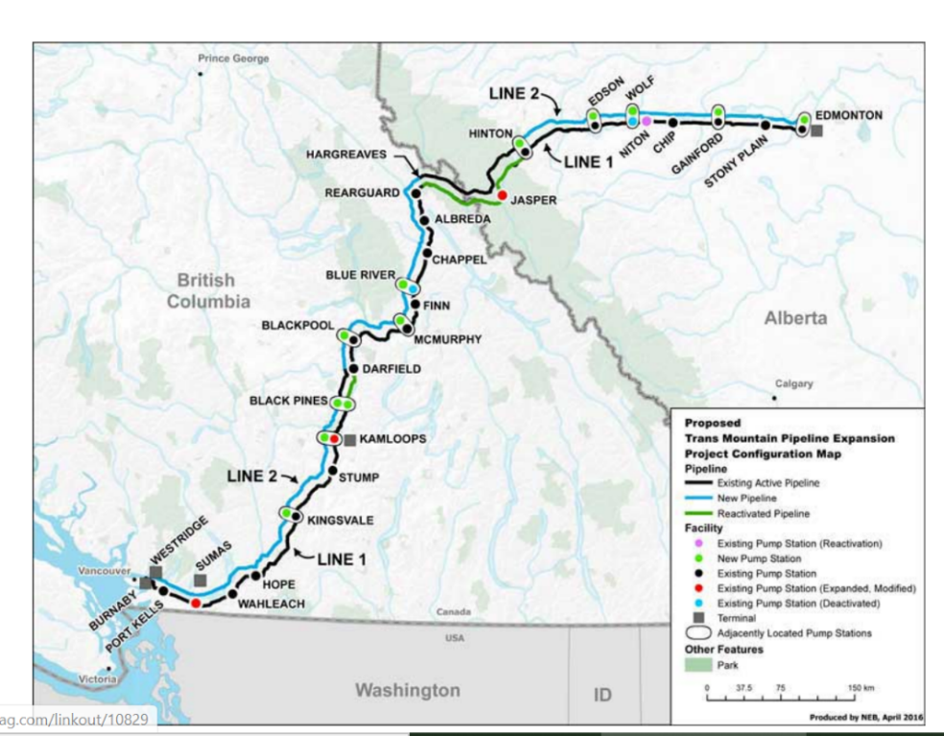
The image above shows the path of the TransMountain Pipeline. The Federal Government purchased and funded the twinning, (doubling capacity), of this existing pipline. What could be some advantages and disadvantages of more oil flowing from Alberta to BC?

Alberta and Saudi oil aren’t necessarily the same thing
On paper, Canada could become energy self-sufficient tomorrow. Every day we produce about 3.9 million barrels of oil per day, and use less than 2 million barrels. What should we do?

