Marine Intertidal Biodiversity
On the field trip students were to collect digital images of a minimum of 10 different organisms that live in the intertidal zone. There must be at least 1 organism from each of the three main intertidal zones, high (supralittoral), middle (mediolittoral) and low (infralittoral).
In Word, Publisher or other formats import and embed the best photo for that organism, (crop if necessary). In text beside the photo include the following:
Name: Bold or underline Scientific Name:
Location discovered:
Identifying Characteristics:
Prey, what does it eat?
Predators, what eats it?

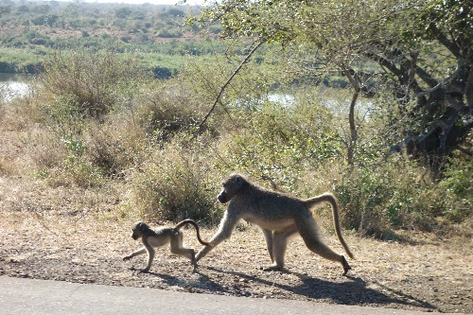
Example:
Name: Chacma Baboon, Papio Ursinus Ursinus
Location: Kruger NP, by Lower Sabie River
Characteristics: Medium sized primate, dark face and longer snout, bare butt, grey/beige back. Lives in large troops.
Prey: Fruit, roots and small animals
Predators: Leopard, Cheetah, Lion, Hyena, Wild Dog, Crocodiles

Final Product: Get all 10 on 2 pages. Then email to me to print in colour on one piece of paper.

