Pulley Lab – mechanical advantage (make-up: complete using data)
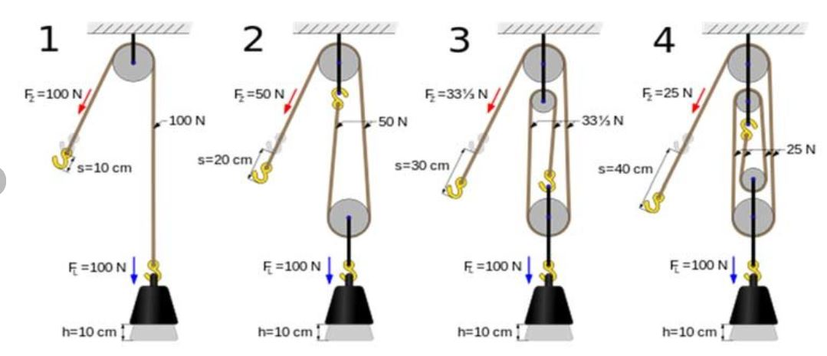
Diagram or system | F_{g} (N) | F_{applied} (N) | Mechanical Advantage | Strands supporting
 | 1.96 N | 1.74 N | F_{g}/F_{a}  = | 1
 | 1.96 N | 1.21 N |  | 2
 | 1.96 N | 0.76 N |  | 3
Diagram | F_{g} (N) | F_{applied} (N) | Mechanical Advantage | Supporting Strands
 | 1.96 N | 0.54 N |  | 4
 | 1.96 N | 0.43 N |  | 5
 | 1.96 N | 0.29 N |  | 6

Questions:
- How does Mechanical Advantage compare to Efficiency? Consider the formula for Work?

- Would a larger pulley have less friction or more? What factors influence the friction in a pulley?

- Is there a maximum of pulleys that can be added to a system?

_{Conclusion:}

